Identifying Root Causes of Global Temperature Change Using Multi‑Source Data Integration and Regression Feature Ranking

Matthew Wybranski
The Pennsylvania State University: Abington Campus
CMPSC 463: Dsgn Analysis Algs
Professor Janghoon Yang
March 18, 2026

Overview
For this project, we were tasked with finding several datasets and merging them into one, and analyzing them to see what is the root cause of global temperature change. My version of the project saw yearly samples of data from across the globe, and how different factors of both human and natural occurrences affect temperature. The main objective of this project was to build a regression-based analytical model to show what are the most influential drivers of this change.

1. Data Collection
I collected 5 datasets containing information on how global temperatures have shifted over the past 250+ years. Most of the data focuses on the human population and its effects on the environment and global temperature. One example of this would be through the use of coal and the release of CO2 emissions. Unfortunately, I was not able to use the solar irradiance table that was provided for us, as it seemed to be encrypted, and I could not figure out how to decrypt the data. However, as you will shortly see later in this report, no other form of activity has the same effect on the environment as the CO2 that humans release. Below are pictures of the code that I used for collecting and merging the data.
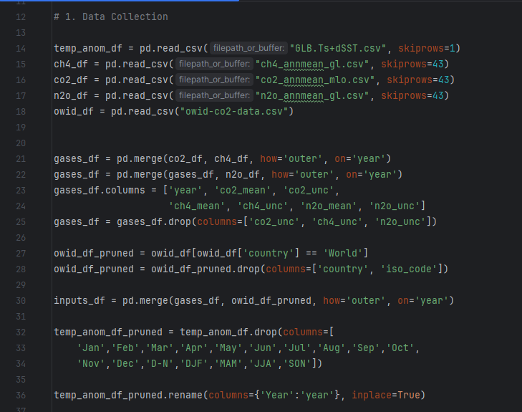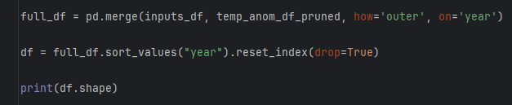

2. Data Preprocessing
For the data preprocessing portion of my code, I mainly tried to clean up the missing values between datasets through several methods. I first added a “years_since_start” column to keep track of how many years have passed since the start year, which was 1750. Next, I added growth columns for CO2, CH4, and N2O to show the amount of growth/difference between the current sample of data and the previous. Then, I make sure “J-D” column or the global temperature column has only numeric values, and I compute the five-year moving averages for both the CO2 and temperature data and add a new column for each. Finally, I interpolate for “co2_mean”, “ch4_mean”, and “n2o_mean”, and I fill any leftover empty columns using pandas’ fill methods. I also print and check the post-preprocessed data at the end of this section.

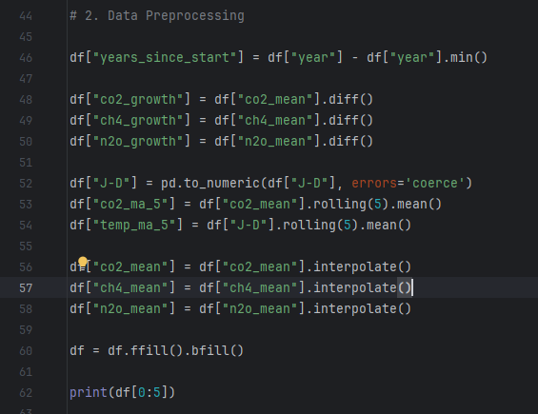
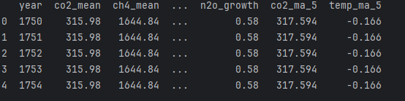

3. Model Development and Root‑Cause Identification via Feature Ranking
For this project, I used linear regression to train my model. I also used SelectKBest and a standard scalar to help with feature selection/ranking the model. Below is my code and the results of the feature selection.
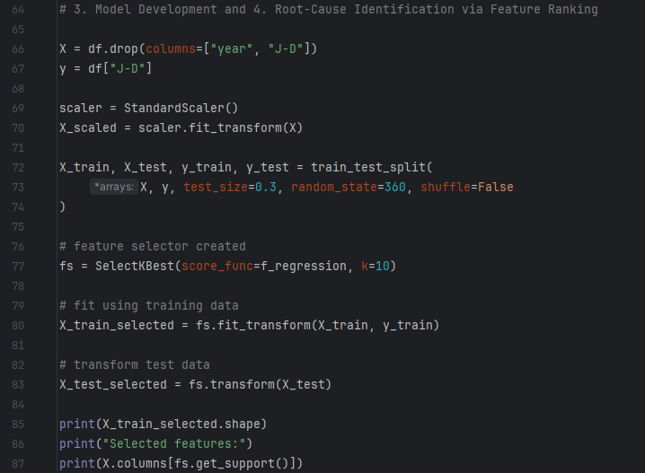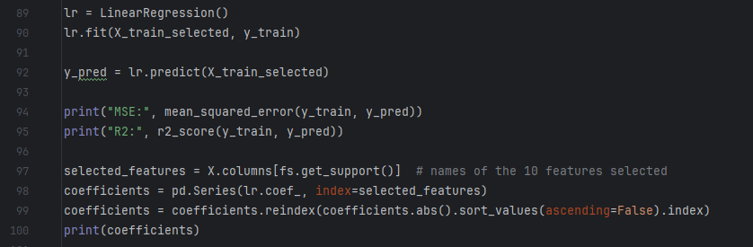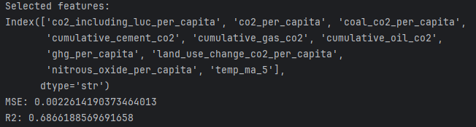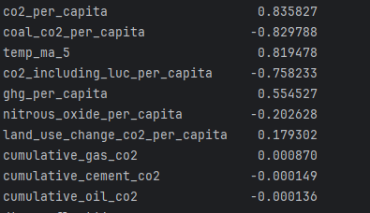
Based on the feature selection, I believe it is clear to see that CO2 has the most impact on driving global temperature change. Not only is co2_per_capita one of the top features, but ghg_per_capita (greenhouse gases) is in the top five as well. This shows that the per-person release of CO2 is important enough to make it a feature when training the model. It can be inferred that CO2 would also outperform natural occurrences based on this feature selection data.

4. Visualization Requirements
Time‑series trends of greenhouse gases vs temperature:
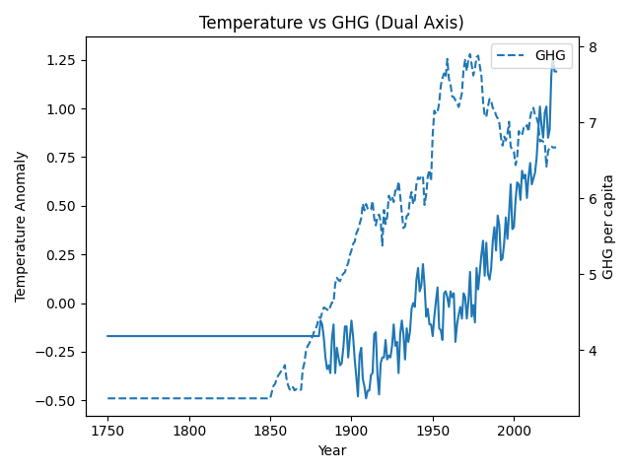
Time‑series trends of CO2 (mean) vs temperature:
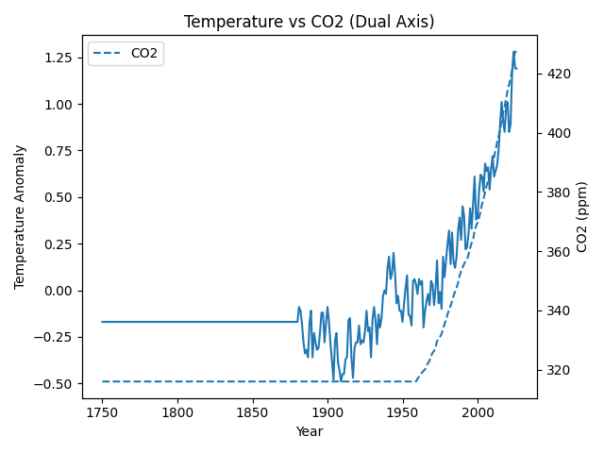
Feature importance bar charts:
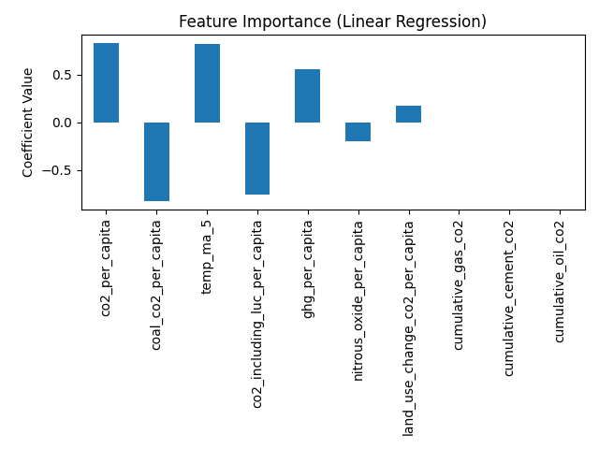
Scatter plots for top features:
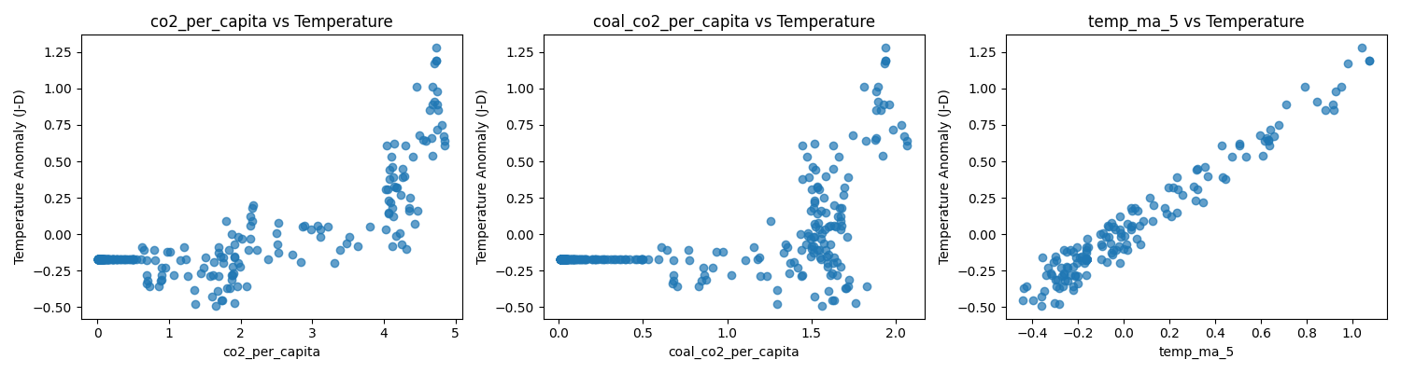

5. Discussion & Conclusion
The factors that appeared to be the strongest and the ones that agree with established climate science the most are CO2 and greenhouse gas factors. These features had the most data collected on them, and as we can see with the different graphs, most accurately line up with rising global temperatures. This supports climate science as it is believed that the more CO2 we release into the atmosphere, the more climate change continues (Lindsey, 2025).
The biggest challenges with this project were the data merging and modeling portions. The datasets were not too difficult to find and use, aside from the solar irradiance one mentioned previously, but combining each dataset and replacing missing/NaN values was more difficult than I had anticipated.
A key limitation of regression models is seen through their ability to identify correlation rather than causation. This means that while regression models can show an association between two features, they can not accurately show how/if one feature can cause changes to the other. Ethical considerations are also very important when working on a project like this. When looking for data, the reliability of said data is key. High-quality data that is also scientifically accurate is the best way to create an accurate, transparent model.
Overall, while it was a difficult project to complete, these datasets were interesting to look at, compare, and merge. While my model could use improvement, I am satisfied with it because I believe that it gets the idea across of how greenhouse gas emissions affect global temperatures.

References
Lindsey, R. (2025, May 21). Climate Change: Atmospheric Carbon Dioxide (J. Miller, Ed.). Climate.gov; National Oceanic and Atmospheric Administration. https://www.climate.gov/news-features/understanding-climate/climate-change-atmospheric-carbon-dioxide

